Software Requirements
Specification
for

MediFriend- Smart Appointment Management System

Version 1.0 approved

Prepared by

Rutuja Pravin Varunkar
Niharika Harish Wagh

25th Feb,2025

Copyright © 1999 by Karl E. Wiegers. Permission is granted to use, modify, and distribute this document.

Table of Contents
Table of Contents ii
Revision History ii
- Introduction 1
  - Purpose 1
  - Document Conventions 1
  - Intended Audience and Reading Suggestions 1
  - Product Scope 1
  - References 1
- Overall Description 2
  - Product Perspective 2
  - Product Functions 2
  - User Classes and Characteristics 2
  - Operating Environment 2
  - Design and Implementation Constraints 2
  - User Documentation 2
  - Assumptions and Dependencies 3
- External Interface Requirements 3
  - User Interfaces 3
  - Hardware Interfaces 3
  - Software Interfaces 3
  - Communications Interfaces 3
- System Features 4
  - System Feature 1 4
  - System Feature 2 (and so on) 4
- Other Nonfunctional Requirements 4
  - Performance Requirements 4
  - Safety Requirements 5
  - Security Requirements 5
  - Software Quality Attributes 5
  - Business Rules 5
- Other Requirements 5
Appendix A: Glossary 5
Appendix B: Analysis Models 5
Appendix C: To Be Determined List 6

Revision History

Name | Date | Reason For Changes | Version
Rutuja Pravin Varunkar  Niharika Harish Wagh | 25th Feb,2025 | First Draft | 1.0

Introduction

Purpose
The Smart Appointment Management System is a web-based platform designed to streamline doctor appointment scheduling, patient management, and hospital administration. It enables patients to book appointments online, doctors to manage schedules and update checkup details, and admins to oversee hospital operations efficiently. The system aims to reduce manual processes, improve hospital efficiency, and enhance patient experience.

Document Conventions

This Software Requirements Specification (SRS) for the Smart Appointment Management System follows standard documentation practices to ensure clarity, consistency, and readability. The following conventions have been used throughout this document:
This document follows the IEEE SRS template conventions:
- Font Style: Times New Roman
- Font Size:
  - Headings: 14 pt, Bold
  - Subheadings: 12 pt, Bold
  - Body Text: 12 pt, Regular
  - Table and Figure Captions: 10 pt, Italic
- Numbering System: Hierarchical numbering (e.g., 1, 1.1, 1.1.1) for sections and subsections.
- Emphasis:
  - Bold for important terms and headings.
  - Italics for references and examples.
- Bullet Points & Numbered Lists: Used for clear organization of items.
- Tables & Figures: Labelled and numbered for easy reference.

Intended Audience and Reading Suggestions

This document is intended for developers, project managers, hospital administrators, and testers. Developers will use it to understand the system architecture and functionality, while project managers will track progress and system capabilities. Hospital administrators will refer to it to assess system usability and its impact on hospital operations. Testers will utilize this document to verify system requirements and ensure expected behavior.

Product Scope

The Smart Appointment Management System is designed to streamline hospital operations by integrating user authentication, appointment scheduling, and administrative controls. Patients, doctors, and admins can securely log in to manage their respective tasks. Patients can view doctor availability and book appointments, while doctors can manage their schedules and update patient records. The admin control panel allows administrators to oversee doctors, appointments, and
system operations efficiently. The system is database-driven using MySQL, ensuring structured and secure data management. Additionally, its scalable architecture allows for future enhancements such as telemedicine integration, making it adaptable to evolving healthcare needs.

References

IEEE Std 830-1998 – IEEE Recommended Practice for Software Requirements Specifications

Author: Institute of Electrical and Electronics Engineers (IEEE)

Version: 1998

Description: This standard provides guidelines for writing clear and well-structured SRS documents.

Source: IEEE Standards

Java Servlet & JDBC Documentation

Author: Oracle Corporation

Version: Latest stable version

Description: Official documentation for Java Servlet API and JDBC for building dynamic web applications.

Source: https://docs.oracle.com/en/

MySQL Workbench User Guide

Author: Oracle Corporation

Version: Latest stable version

Description: Official user guide for MySQL Workbench covering database design, development, and administration.

Source: https://dev.mysql.com

Apache Tomcat Configuration Guide

Author: Apache Software Foundation

Version: Latest stable version

Description: Official documentation for configuring and managing Apache Tomcat server.

Source: https://tomcat.apache.org

IEEE SRS Standard Template

Author: Karl E. Wiegers

Version: IEEE Template

Description: Template for preparing Software Requirements Specification documents following IEEE guidelines.

Source: IEEE Publications

Overall Description

Product Overview

The Smart Appointment Management System is a comprehensive web-based solution designed to streamline the process of doctor appointment scheduling, patient management, and hospital administration. The system is developed as a standalone product aimed at reducing the inefficiencies associated with manual appointment booking, ensuring real-time scheduling, and improving hospital workflow. It enhances operational efficiency by automating routine administrative tasks, minimizing errors, and providing detailed reports for informed decision-making.
The system operates in a web-based environment, enabling patients, doctors, and administrators to manage appointments and medical records remotely. It features a secure user authentication system, a doctor dashboard for managing schedules and updating patient records, and an admin control panel for overseeing doctors, appointments, and hospital operations. The frontend is built using HTML, CSS,

JavaScript, Bootstrap, JSP, and FontAwesome, while the backend is developed with Java Servlets and JDBC. The system runs on an Apache Tomcat server, with MySQL serving as the database for structured and secure data management. Its scalable architecture allows for future enhancements, such as telemedicine integration, ensuring adaptability to evolving healthcare needs.
A High-Level-Diagram depicting the interaction between major components is shown below:

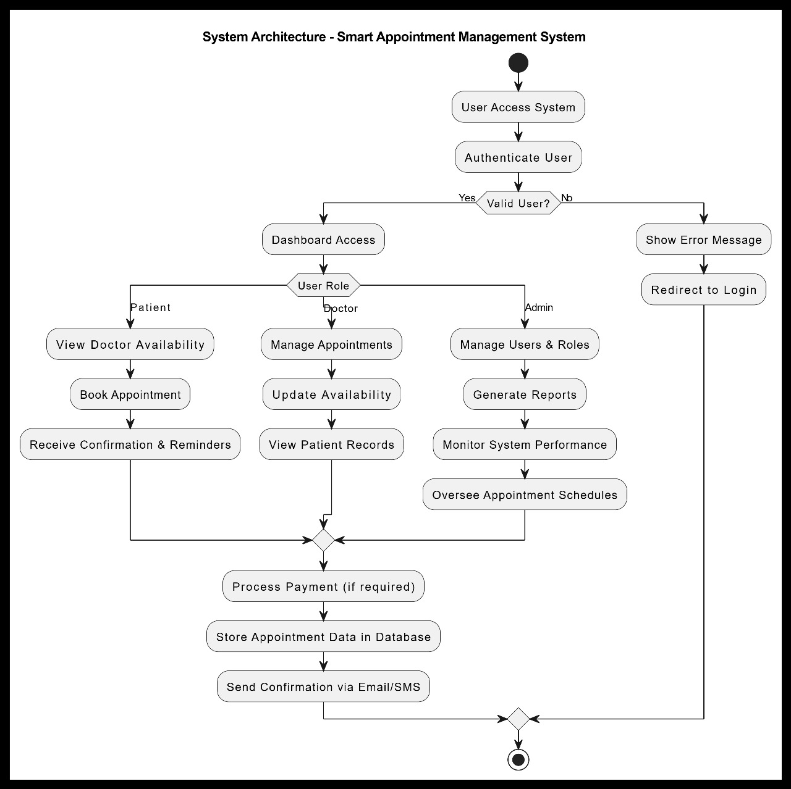
Figure 1.1 High Level Design

Product Functions

The Smart Appointment System includes several key functionalities to enhance hospital operations

and patient management. It features User Profile Management, allowing patients and doctors to create and update their profiles efficiently. The system also supports Doctor Scheduling & Patient Record Updates, ensuring that doctors can manage their availability while maintaining up-to-date patient records. Additionally, it provides Appointment Booking & Management, enabling patients to book, reschedule, or cancel appointments seamlessly. To oversee hospital operations, the system includes an Admin Dashboard, offering insights and management tools for optimizing workflows and enhancing overall efficiency.

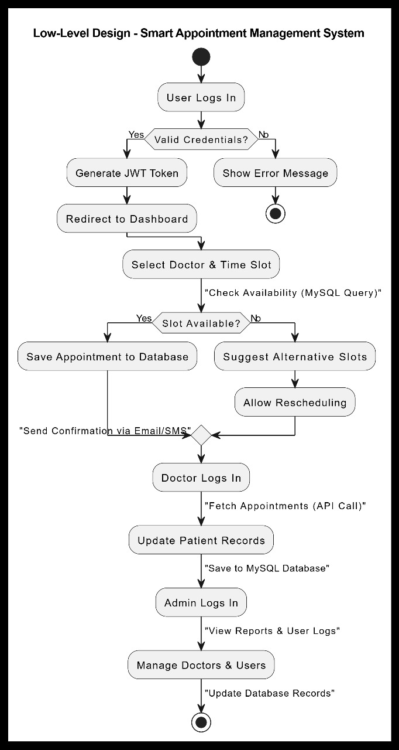
Figure 1.2 Low level Design

User Classes and Characteristics

- Patients: Book appointments and view medical history.
- Doctors: Manage patient schedules and update records.
- Admins: Oversee system users, doctors, and appointments.

Operating Environment

- Frontend: HTML, CSS, JavaScript, Bootstrap, JSP, FontAwesome.
- Backend: Java Servlets, JDBC.
- Server: Apache Tomcat.
- Database: MySQL.
- Development Tools: Eclipse, MySQL Workbench.
- Supported OS: Windows/Linux/MacOS.

Design and Implementation Constraints

The system must handle real-time database updates efficiently, though network latency may impact performance. To ensure security, role-based access control will be implemented, restricting access based on user roles and permissions. Additionally, the system must support multiple concurrent users, ensuring smooth operation and responsiveness even under high user load
Below shows how the data flows through the system:-
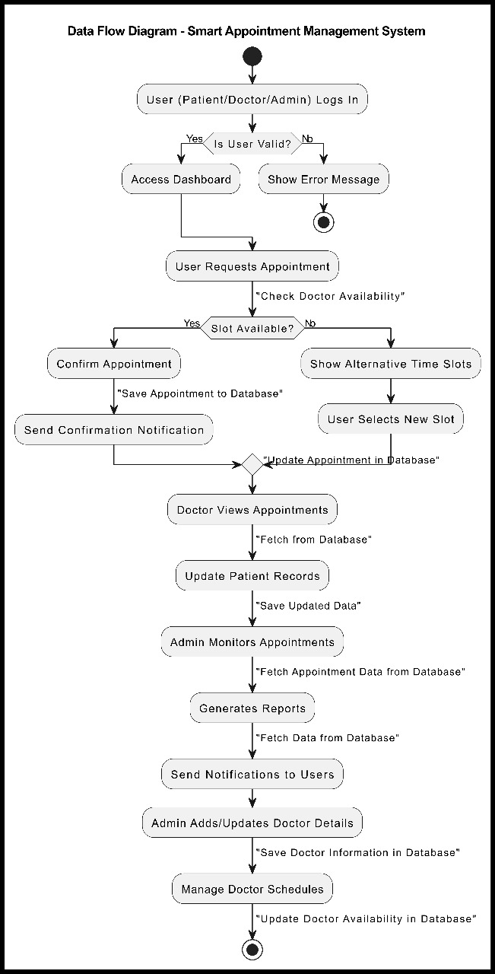

Figure 1.4 Data-flow diagram

User Documentation

- User Manual: For patients, doctors, and admins.
- Developer Documentation: API and database schema details.
- Troubleshooting Guide: Common errors and solutions.

Assumptions and Dependencies

- Stable Internet Connection – The system relies on a consistent and stable internet connection for real-time data synchronization, communication between client and server, and seamless user experience. Any network disruptions may affect system performance.
- Java Runtime Environment (JRE) Installation – The application requires JRE to be installed on the host machine to execute Java-based components. Compatibility with the required JRE version must be ensured for proper functionality.
- Apache Tomcat Configuration – The system depends on Apache Tomcat as the web server and servlet container. It must be properly installed and configured to support the deployment and execution of the application, ensuring compatibility with the required Java version and system
settings.

External Interface Requirements

3.1 User Interfaces

The system will provide an intuitive and user-friendly dashboard tailored to the needs of patients, doctors, and administrators, ensuring that each user type can easily navigate and access relevant functionalities. Patients will have access to a simplified interface for viewing available doctors, booking appointments, and managing their medical history. A dedicated appointment scheduling calendar will allow patients to conveniently select available time slots based on doctors' schedules. Doctors will have a specialized interface for managing their profiles, updating their availability, and viewing their upcoming appointments. This will help them efficiently organize their schedules and provide better patient care. Administrators will be provided with a comprehensive control panel to oversee and manage the entire system's operations, including user management, appointment monitoring, system configurations, and generating reports. The design of all user interfaces will focus on providing a smooth, responsive, and efficient experience for all users.

3.2 Hardware Interfaces

- Device Compatibility
PCs & Laptops: Windows, macOS, or Linux-based systems.
Tablets: iOS (iPads) and Android tablets for mobile access.
- Minimum Hardware Requirements
Processor: Intel Core i3 (or AMD equivalent) or higher. (Recommended: i5/i7 for better performance)
RAM: Minimum 4GB (Recommended: 8GB+ for multitasking)
Storage: At least 100GB free space (SSD preferred for speed)
Display: Minimum 1280x720 (HD) (Recommended: Full HD 1920x1080)
Internet: Stable Wi-Fi or Ethernet for real-time updates.

3.3 Software Interfaces

1) Backend Technology
- Developed using Java, leveraging Servlets for handling client requests.
- JDBC (Java Database Connectivity) ensures efficient communication with the database.
- Follows MVC (Model-View-Controller) architecture for modular design and maintainability.
2) Database Management
- Uses MySQL as the relational database for secure storage of user details, doctor schedules, and appointments.
- Supports optimized queries, indexing, and ACID compliance for efficient data retrieval and integrity.
3) Development Environment
- Developed using Eclipse IDE, offering code completion, debugging tools, and seamless integration with Java-based frameworks.
- Supports version control (Git), build automation (Maven/Gradle), and API testing (Postman) for smooth development.
3.4 Communication Interfaces

Secure Web Communication (HTTP/HTTPS)
- The system communicates using HTTP/HTTPS protocols to ensure secure data transfer between the client-side UI (React.js) and the backend (Java Servlets).
- HTTPS (SSL/TLS encryption) is enforced to protect sensitive data like user credentials and medical records from unauthorized access.
- RESTful API endpoints handle requests such as appointment booking, schedule retrieval, and user authentication.
- MySQL connectivity using JDBC drivers.

- The backend connects to the MySQL database using JDBC (Java Database Connectivity) drivers for efficient query execution and transaction management.
- Supports prepared statements to prevent SQL injection and ensure secure data handling.
- Optimized connection pooling is used for performance improvements, reducing database load during high traffic.
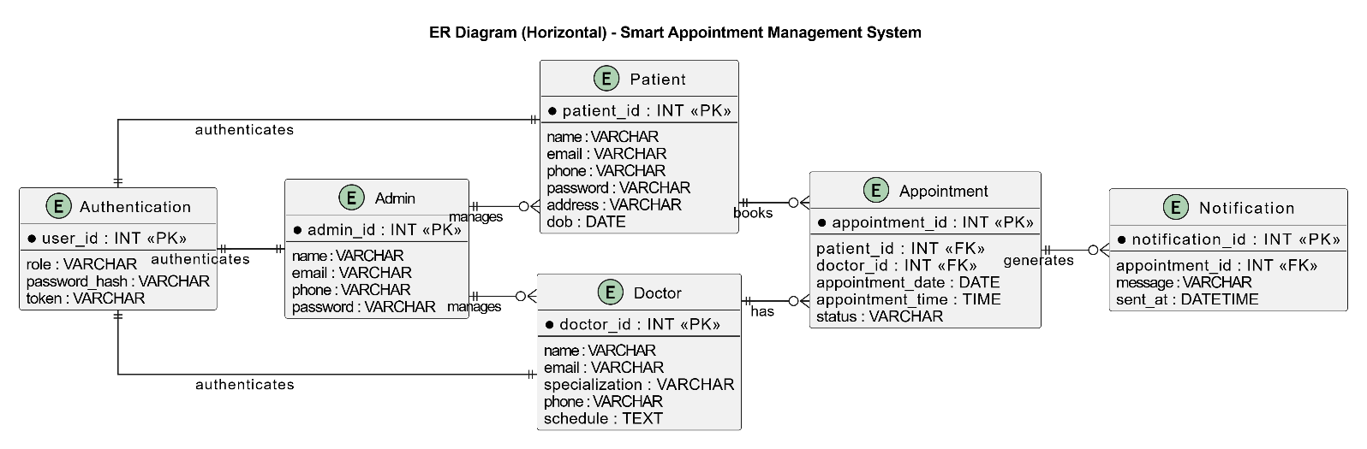
Here is layout of database in form of Entity-Relationship diagram:

Figure 1.5

System Features

4.1 User Module

- User Registration & Secure Login.
- Book, reschedule, or cancel appointments.
- View appointment history.

4.2 Doctor Module

- Login & profile management.
- View daily appointment schedule.
- Update patient records after checkup.

4.3 Admin Module

- Add, remove, and manage doctor profiles.
- Track number of booked appointments.
- Manage system users and security settings.

Use-case diagram:

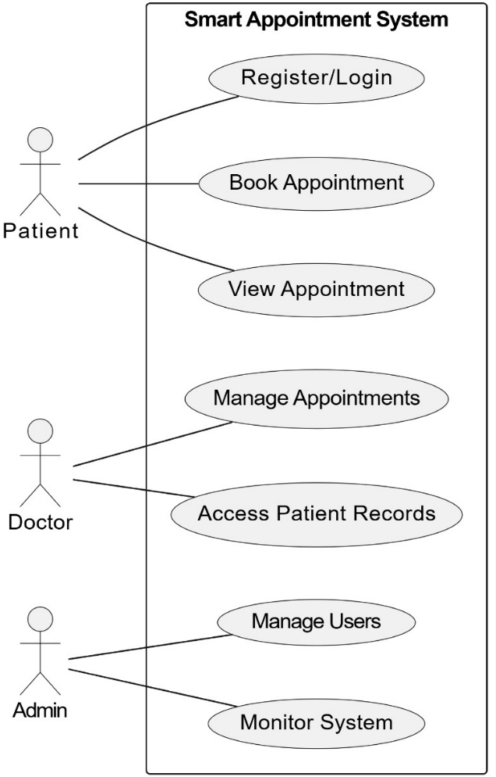

Figure 1.6

Other Nonfunctional Requirements

5.1 Performance Requirements

The Smart Appointment System must be capable of handling multiple concurrent users efficiently without experiencing significant performance degradation. The system should support simultaneous appointment bookings, real-time schedule updates, and seamless data retrieval to ensure a smooth user experience. Given the dynamic nature of hospital operations, real-time processing of appointment scheduling is essential, minimizing delays and ensuring instant confirmation for both patients and doctors. The backend should be optimized for high availability, low latency, and quick response times, even during peak usage hours.

5.2 Security Requirement

- Security is a top priority to protect sensitive patient and hospital data. The system must implement role-based access control (RBAC), ensuring that users—whether patients, doctors, or administrators—have access only to the features and data relevant to their roles. All sensitive user information, such as medical history and personal details, must be encrypted both at rest and in transit to prevent unauthorized access. Additionally, the authentication system should include secure login mechanisms, such as multi-factor authentication (MFA) and OAuth-based login, to enhance protection against potential breaches.

5.3 Software Quality Attributes

The system must ensure high standards of software quality across different attributes:
- Availability: The platform should be accessible 24/7, ensuring uninterrupted service for appointment bookings, rescheduling, and patient record management. Downtime should be minimized through proper server redundancy and failover mechanisms.
- Reliability: The system must maintain data consistency and integrity, ensuring that appointment records, doctor schedules, and patient data remain accurate despite high traffic or unexpected errors. Robust error handling and exception management should be implemented to prevent failures and data corruption.
- Scalability: The application should be easily expandable, allowing for the addition of new features such as telemedicine, AI-powered appointment recommendations, and integration with wearable health devices. The architecture should support horizontal scaling to accommodate a growing number of users and healthcare institutions over time.
- Maintainability: The system should be modular and well-documented, allowing for easy updates and troubleshooting. Developers should follow coding standards and best practices to ensure future enhancements can be implemented without disrupting existing functionality.
- Security: Strong encryption techniques should be used for storing and transmitting sensitive patient data. Secure authentication mechanisms like multi-factor authentication (MFA) and role-based access control (RBAC) should be enforced to prevent unauthorized access. Regular security audits and vulnerability assessments must be conducted to ensure compliance with healthcare data protection regulations.
- Performance Efficiency: The system should optimize response times and minimize latency, ensuring that appointment scheduling and patient record retrieval occur in real-time. Efficient database indexing and caching mechanisms should be implemented to handle concurrent user requests without performance degradation.
- User Experience (UX): The interface should be intuitive, responsive, and accessible across multiple devices, including desktops, tablets, and mobile phones. The design should follow UI/UX best practices to enhance usability and reduce the learning curve for doctors, patients, and administrators.
- Interoperability: The system should be compatible with external healthcare platforms, electronic medical record (EMR) systems, and third-party APIs. This ensures seamless data exchange between hospitals, insurance providers, and diagnostic centers, improving overall healthcare service efficiency.

Appendix A: Glossary

SRS: Software Requirements Specification

JSP: Java Server Pages

JDBC: Java Database Connectivity

UI: User Interface

HTTP/HTTPS: Hypertext Transfer Protocol / Secure

IDE: Integrated Development Environment

JRE: Java Runtime Environment

CRUD: Create, Read, Update, Delete

Appendix B: Analysis Models

- Data Flow Diagram (DFD): Illustrating data flow between system modules.
- Entity-Relationship Diagram (ERD): Mapping relationships between data entities like patients, doctors, and appointments.
- Class Diagrams: Showing classes, attributes, and relationships within the system.
- Use-case diagram: It visually represents the interactions between users (actors) and a system, showcasing various functionalities (use cases) and their relationships to define system behavior.

Appendix C: To Be Determined List

- Payment Gateway Integration: Final decision on integrating third-party payment gateways.
- Notification System: Selection of email/SMS APIs for appointment reminders.
- Telemedicine Integration: Potential future feature for virtual consultations.
- Mobile App Development: Consideration for a cross-platform mobile application.

